*A Mini Project report on*

**FARM FUTURO**

A Machine Learning-Based Crop Recommendation System for Precision Agriculture and Analysis of Agricultural Datasets.

*submitted in partial fulfillment of the course*

CSE-1006: Foundation of Data Analytics

Under Guidance of Prof. Deepasikha Mishra

By

22BCE7952 Gaikwad Jaydeep Shamrao

22BCE8609 Gourab Choudhury



School of Computer Science & Engineering

VIT-AP UNIVERSITY, INAVOLU, AMARAVATI

November,2023

**INDEX**

01. ABSTRACT

02. INTRODUCTION

03. PROBLEM STATEMENT AND OBJECTIVE

04. WORKING WITH DATA SET

05. EXTRACTING DATA

06. DATA CLEANING

07. DATA SORTING

08. PREDICTION/ANALYSIS USING ML TECHNIQUE

09. ALGORITHM ANALYSIS &RESULTS

10. PLOTS

11. CONCLUSION

**1.ABSTRACT**

FARM FUTURO is a cutting-edge Machine Learning (ML) project designed to address the challenges faced by farmers in making informed crop decisions. This innovative system utilizes advanced ML algorithms to analyze user-provided inputs, such as geographical location (states), crop preferences (cereals, pulses, fruits, cash crops), and environmental factors (rainfall, temperature,humidity, soil pH). FARM FUTURO aims to empower farmers with precise and timely recommendations, guiding them towards optimal crop selection based on their specific conditions and seasonal variations. This project represents a pivotal advancement in precision agriculture, fostering sustainable farming practices and maximizing agricultural productivity.

The heart of FARM FUTURO lies in its sophisticated ML algorithms that analyze historical agricultural data, climatic patterns, and soil conditions. By employing advanced data analytics techniques, the system identifies patterns and correlations that traditional farming methods may overlook. This enables FARM FUTURO to offer precise and timely crop recommendations that are not only suited to the farmer's preferences but also optimized for the specific environmental conditions of the region.

Key features of FARM FUTURO include its ability to predict the most suitable crops for cultivation based on real-time and historical data, taking into account the variations in temperature, rainfall, and soil pH throughout the year. The system also considers seasonal factors, ensuring that farmers receive recommendations tailored to the specific planting and harvesting windows for each crop.

FARM FUTURO represents a significant step forward in the realm of precision agriculture, harnessing the power of machine learning to empower farmers with actionable insights for informed decision-making. As agriculture faces increasing challenges posed by climate change and resource constraints, FARM FUTURO stands as a beacon of innovation, offering a scalable solution to enhance agricultural productivity, profitability, and sustainability.

**2.INTRODUCTION**

Agriculture, acknowledged as the backbone of many economies, confronts escalating challenges attributed to climate variability and the imperative for sustainable resource management. In light of these challenges, FARM FUTURO emerges as a pioneering solution, introducing a state-of-the-art Machine Learning-based crop recommendation system. Conventional farming practices often grapple with the incapacity to harness diverse datasets for precision in decision-making, resulting in suboptimal crop choices and inefficient resource utilization. Recognizing this gap, FARM FUTURO strategically incorporates user inputs and deploys sophisticated ML algorithms to predict the most suitable crops for cultivation, taking into account not only regional climatic conditions but also essential factors such as soil health and pH analysis.

In this dynamic landscape, where traditional approaches fall short in considering the intricacies of soil characteristics, FARM FUTURO stands as a beacon of innovation. By integrating soil health and pH analysis into its predictive framework, the system ensures a comprehensive understanding of the agricultural ecosystem. This holistic approach aims to guide farmers toward optimal crop selection, considering the intricate interplay between environmental conditions, soil health, and crop viability.

This introduction underlines the imperative of such a comprehensive system in modern agriculture, emphasizing the multifaceted nature of factors influencing crop success. FARM FUTURO, through its integration of soil health and pH analysis, not only addresses the challenges posed by climate variability but also enhances the precision and sustainability of agricultural practices. The subsequent sections will delve into the key features and objectives of FARM FUTURO, shedding light on its potential to revolutionize farming practices in the face of contemporary agricultural complexities.

**3.PROBLEM STATEMENT**

The contemporary agricultural landscape grapples with mounting uncertainty due to unpredictable climate patterns and the urgent need for sustainable farming practices. Farmers face the intricate challenge of selecting crops that not only align with their preferences but also thrive in the diverse and often challenging environmental conditions specific to their regions. Traditional methods lack the precision needed to navigate these challenges, resulting in suboptimal yields and resource inefficiencies.

Highlighting the severity of the situation, recent estimates reveal that 29.32% of India's Total Geographical Area (96.40 Million Hectares) is experiencing land degradation, a notable increase from 28.76% in 2003-05. States such as Rajasthan, Maharashtra, Gujarat, Jammu & Kashmir, Karnataka, Jharkhand, Odisha, Madhya Pradesh, and Telangana contribute 24% to this degraded area. Water erosion, vegetation degradation, and wind erosion emerge as primary contributors. Additionally, desertification in arid, semi-arid, and dry sub-humid regions has cumulatively increased by 1.16 Million Hectares from 2003-05 to 2011-13.

**OBJECTIVE**

In response to these challenges, FARM FUTURO aims to address the critical problem by proposing a Machine Learning-based crop recommendation system that leverages the power of data analytics. The system will provide farmers with tailored insights, considering factors such as geographical location, crop preferences, rainfall, temperature, and notably, soil pH. By integrating soil health into its predictive model, FARM FUTURO seeks to empower farmers with recommendations that optimize crop selection, enhance productivity, and contribute to sustainable agricultural practices. The objective is to offer a holistic solution that guides farmers in making informed decisions, ultimately mitigating the impact of environmental complexities on crop yields and fostering sustainable farming practices.

**4.WORKING WITH DATASET**

**Data Content:**

The dataset encompasses crucial agricultural parameters, including:

State (geographical location)

Divisions(type of crop, e.g., cereals, pulses, fruits, etc.)

Average rainfall of the area

pH of the soil

Average Temperature suitable for growth of Crop

Humidity of the area

Season in which the crop is to be grown

Crop to be grown in favorable conditions

Parameters and their data types can be observed and also tail of Dataset is given for reference:

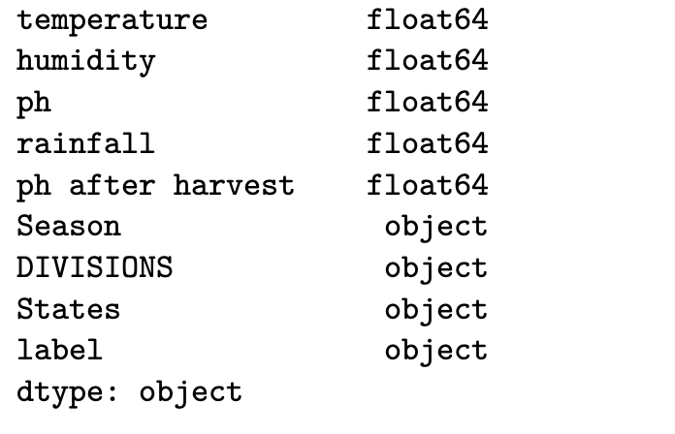

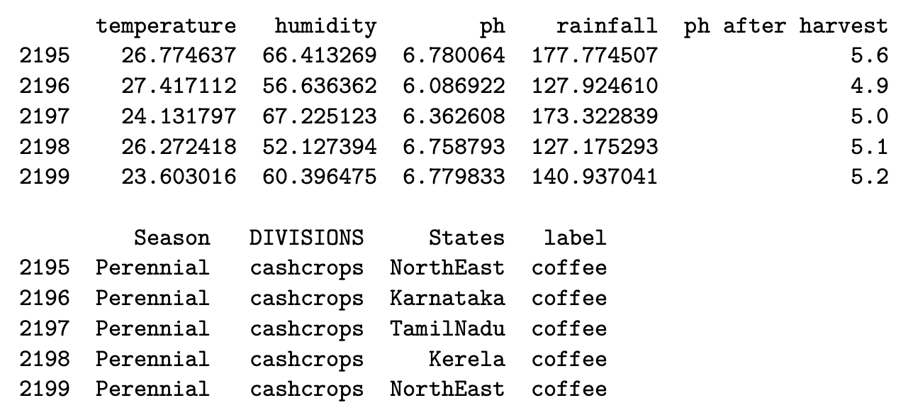

**5.EXTRACTING DATA**

**Data Source:**

The primary dataset underpinning this project is sourced from meticulously collected observations by the National Institute of Agricultural Extension Management (MANAGE). These observations were methodically obtained through surveys and subsequently submitted to the Department of Agriculture Cooperation and Farmers Welfare, operating under the Ministry of Agriculture and Farmers Welfare.

The dataset, curated by MANAGE, serves as a rich repository of agricultural insights spanning diverse regions. The structured format of the survey responses, coupled with the collaborative efforts with the Department of Agriculture Cooperation and Farmers Welfare, accentuates the credibility and significance of this dataset within the context of the project. Acting as a cornerstone, this dataset lays the foundation for the development of a machine learning-based crop recommendation system. Its objective is to harness these observations to furnish tailored insights, facilitating optimized and sustainable agricultural practices.

**Data Volume:**

The primary dataset contains about 2,200 observations, each observation containing agricultural parameters such as geographical location (states), crop preferences (cereals, pulses, fruits, cash crops), and environmental factors (rainfall,humidity, temperature, soil pH).The data of about 23 geographical regions of India and 22 major crops in mentioned in the dataset with each crop having minimum 100 observations.

**6.DATA CLEANING**

**Data Cleaning Methodology:**

The primary dataset contains about 10 to 20 observations with missing values which have been cleaned and rectified by using pandas.Also names of some States have been changed recently which have been replaced with new one.

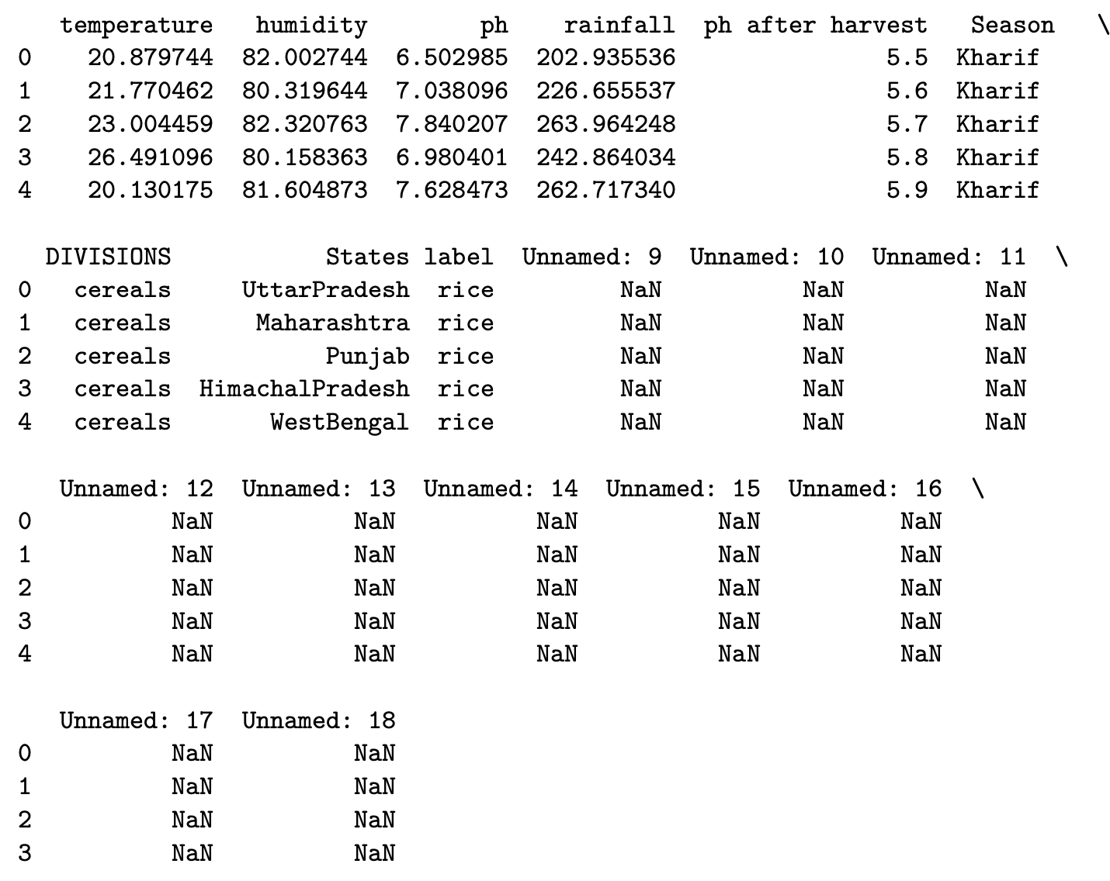

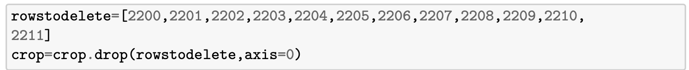

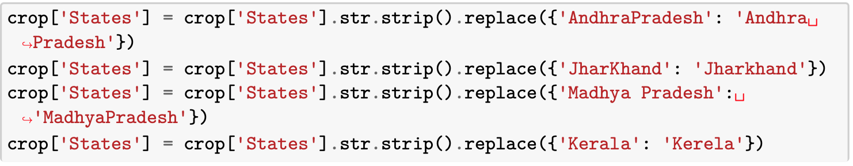

**7.DATA SORTIN**

**G**

The primary dataset has been sorted with respect to the States and then it is grouped by the crops grown in a particular region with the count of total observations.

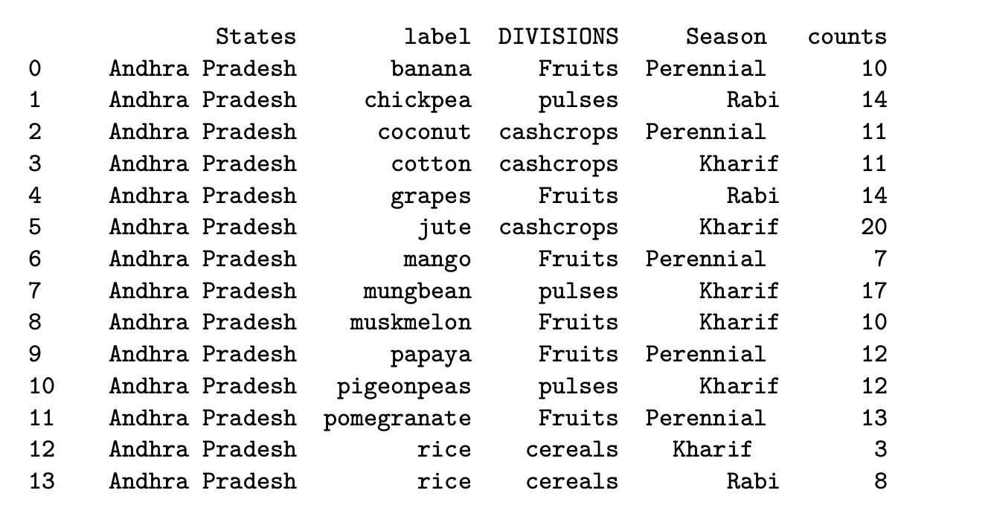

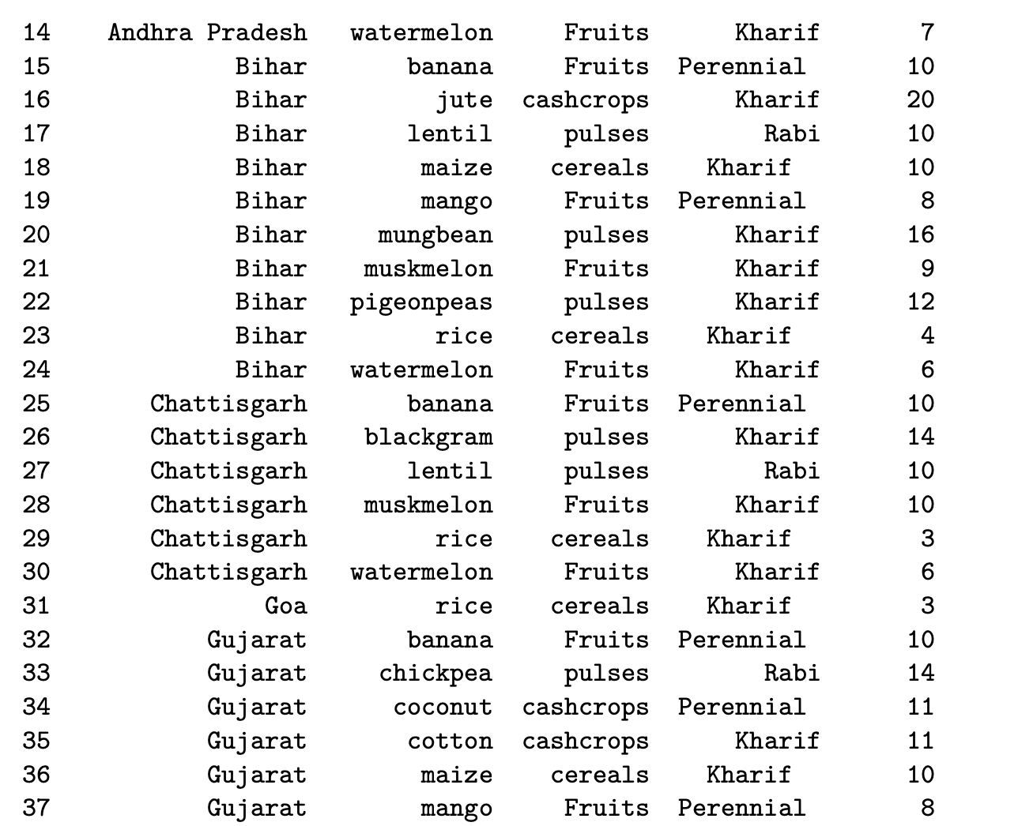

**8.PREDICTION USING ML TECHNIQUE**

**Machine Learning Algorithm:**

The machine learning algorithm used in this Project is the Decision Tree Classifier. A decision tree classifier is a type of supervised learning algorithm that uses a tree-like structure to make decisions and predictions. The algorithm works by recursively splitting the data into smaller and smaller subsets based on certain criteria, until it reaches a final decision or prediction.

The code prompts the user to input values for the features 'temperature', 'humidity', 'pH', 'rainfall', 'divisions', and 'States'. The code encodes the user input for the categorical features using the LabelEncoder objects stored in 'encoder_dict'. The code converts the user input into a Pandas DataFrame named 'user_df'. The code separates the target variable 'label' from the features in the training data. It then splits the training data into training and testing sets using train_test_split.Then code initializes a Decision Tree Classifier object named 'model'.The code predicts the label for the user input using the trained model. The code prints the predicted label for the user input.

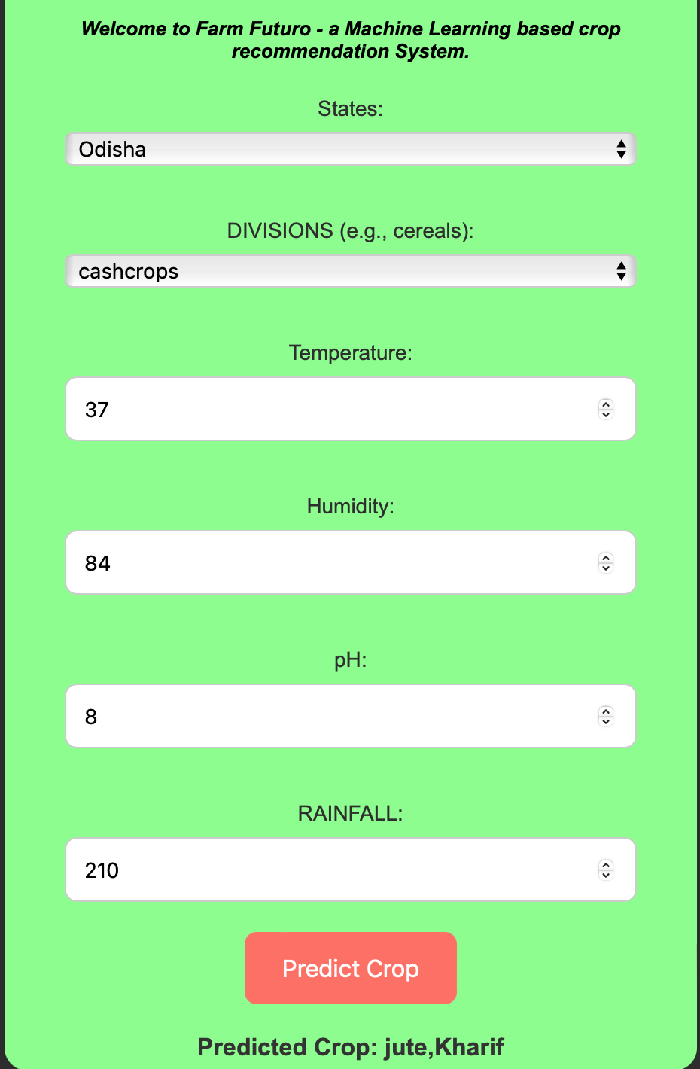

**9.** **ALGORITHM ANALYSIS &RESULTS**

**Different Algorithm used and analysis**

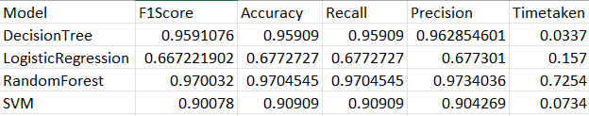

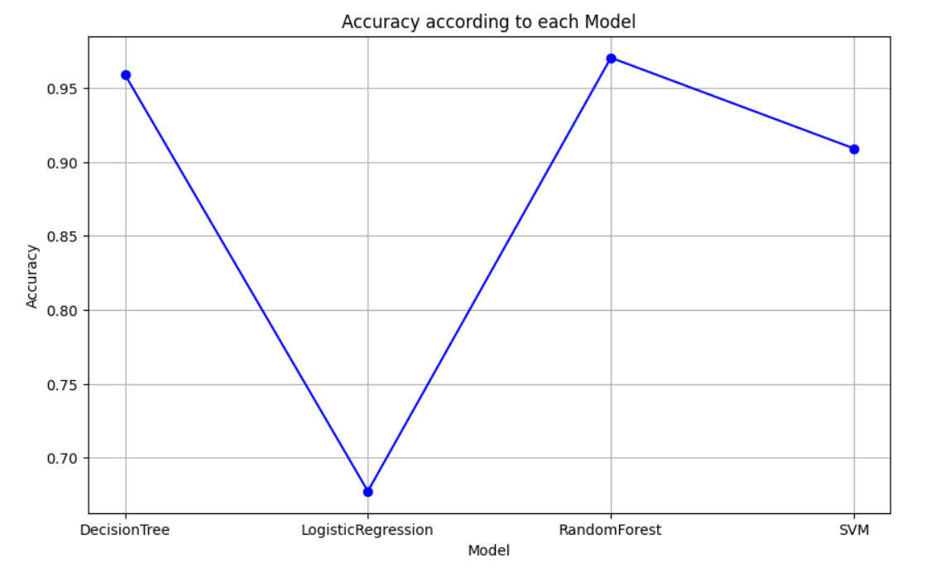

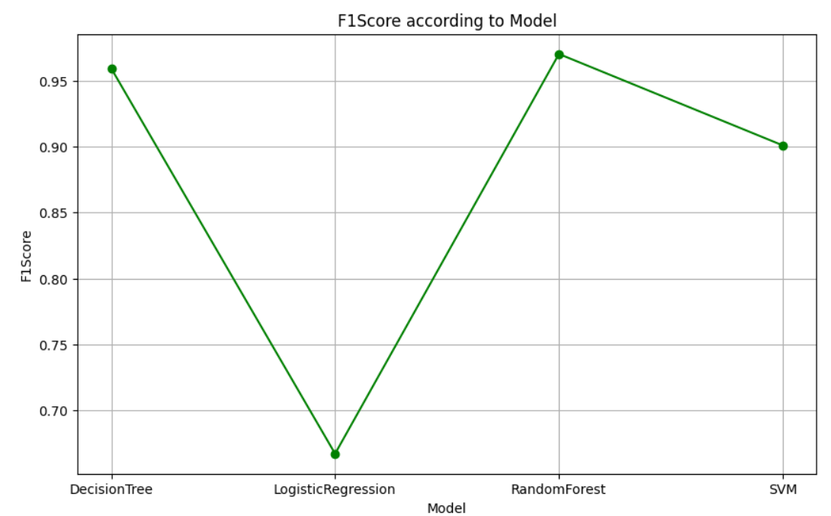

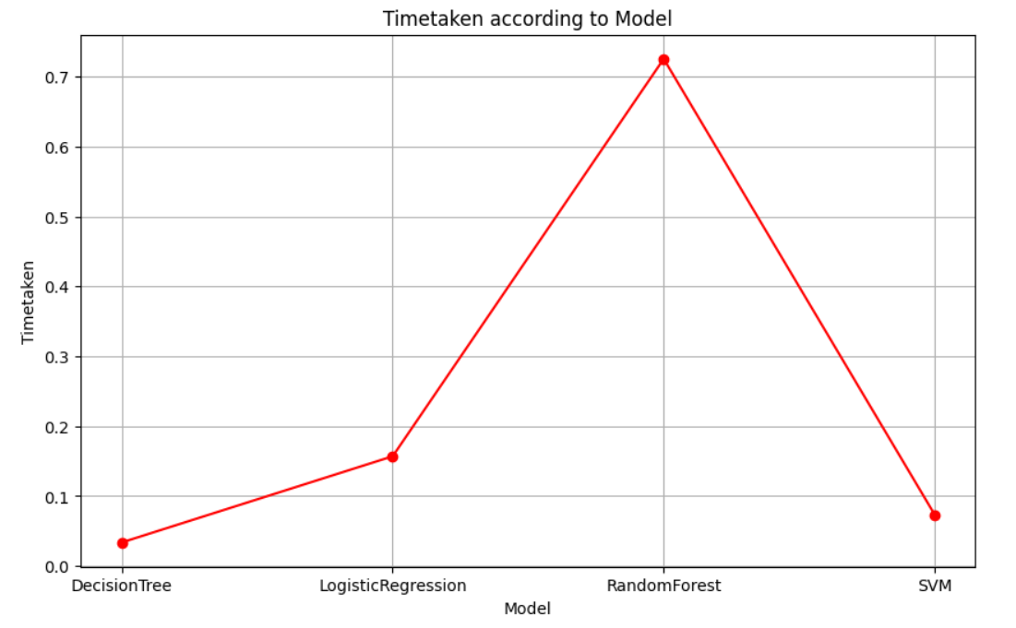

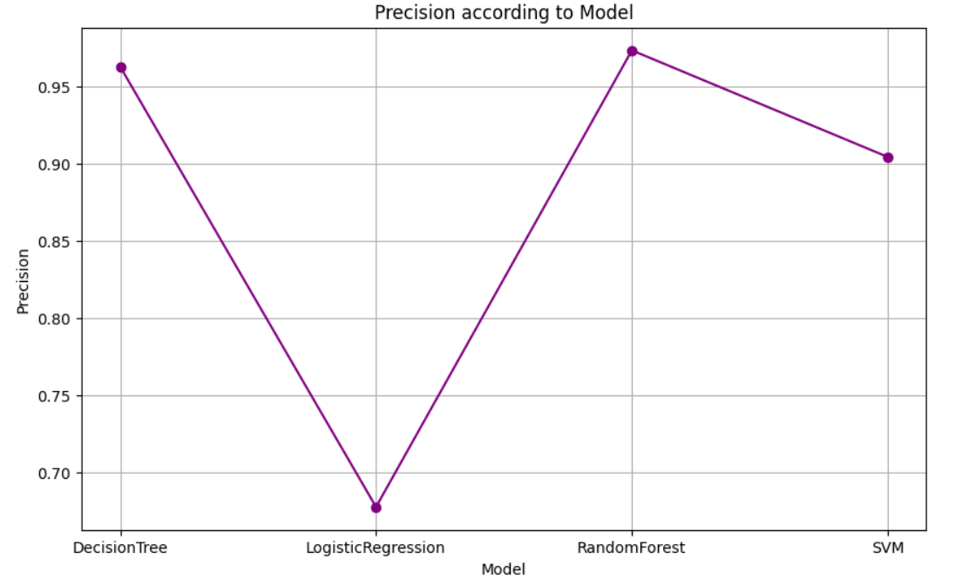

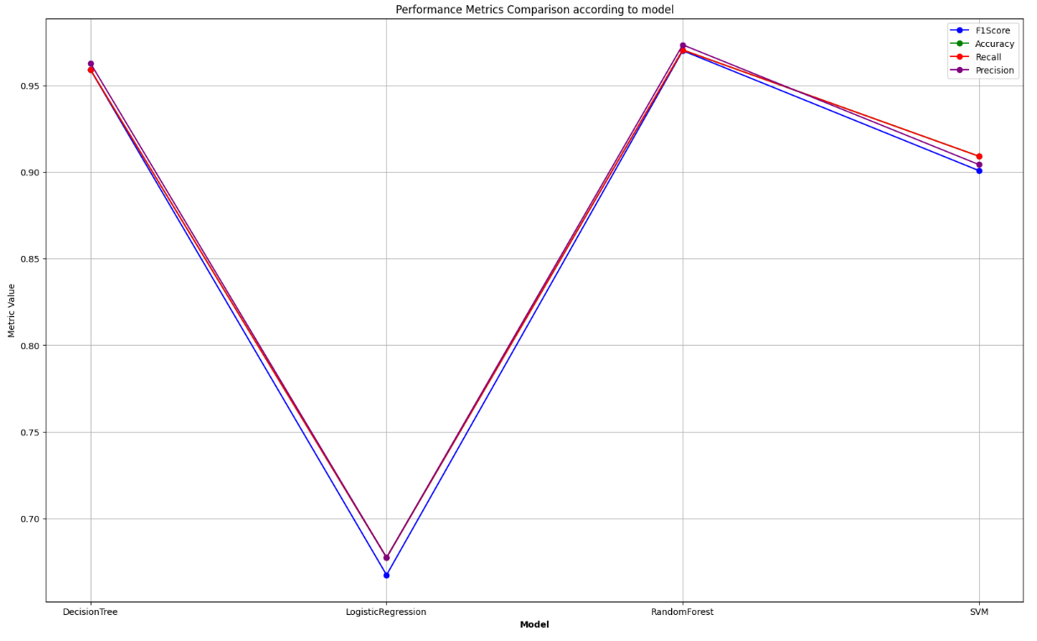

The **Decision Tree** Machine Learning Algorithm recommends the Crop and the Season in which crop to be grown based on the user's input. The recommendation of the Crop matches with the Crop pattern in the particular region with an accuracy of around 90% to 95%.

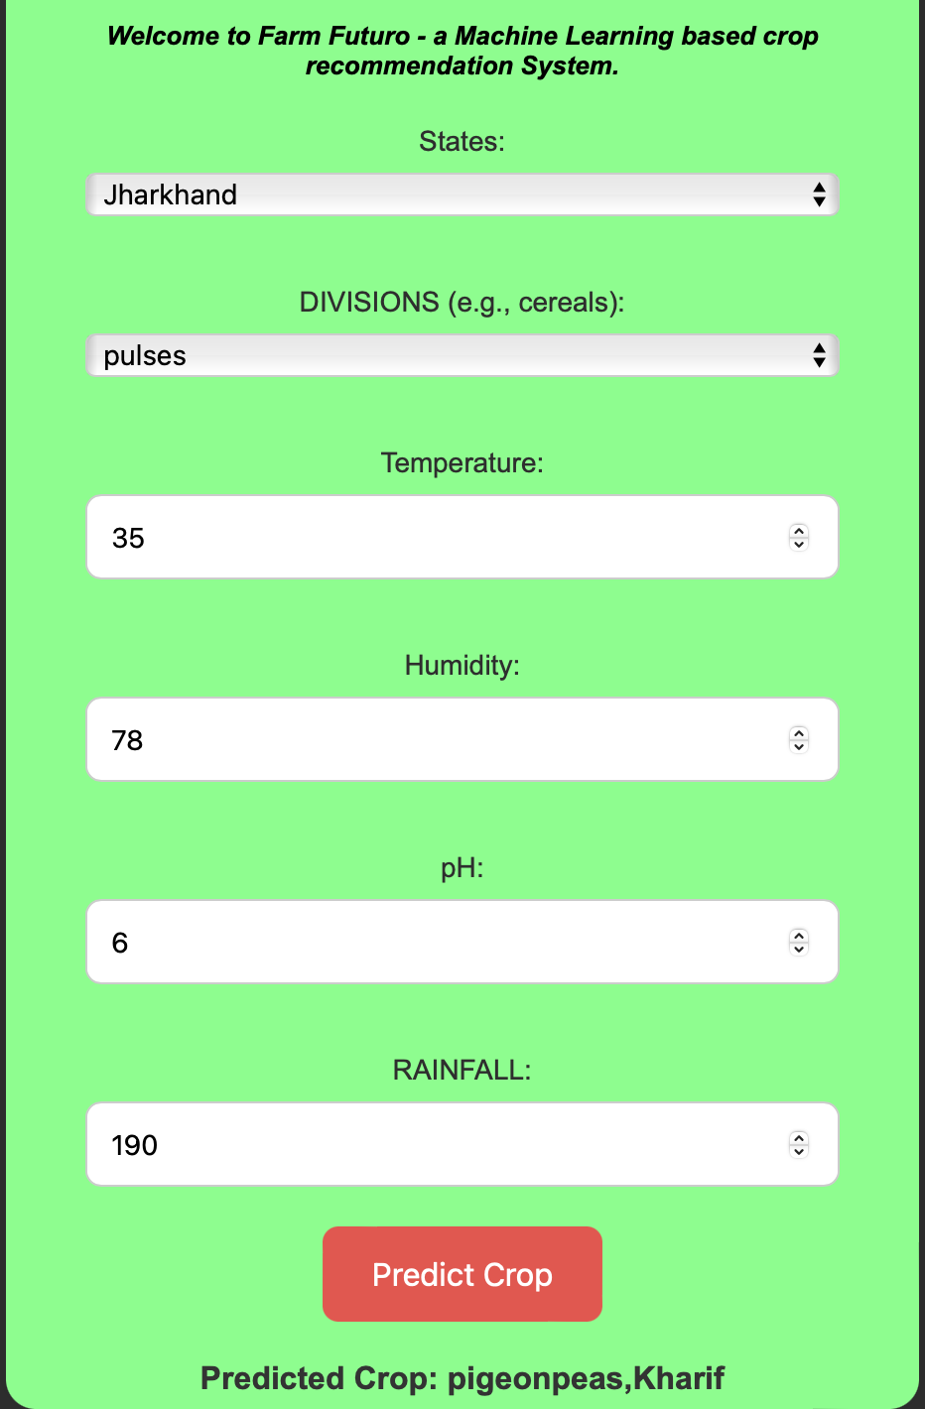

**10.PLOTS**

The Plots are one of the important way to represent our data in understandable format.Many points can be concluded by representing the DataSet in Plots form.

1.Crop Distribution in Andhra Pradesh.

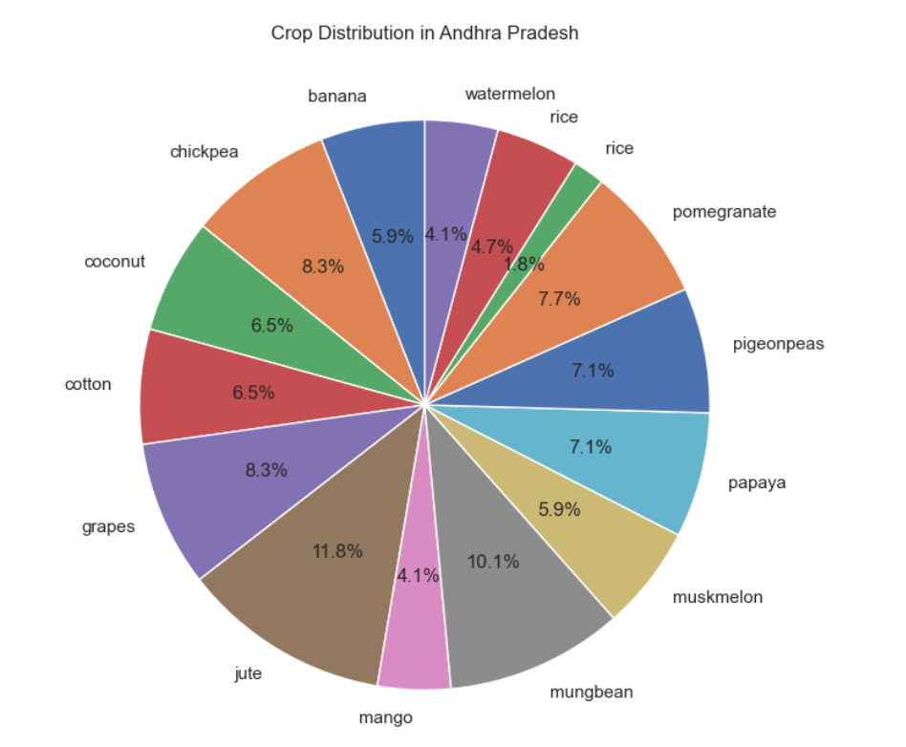

2.Division wise crop Distribution in Bihar.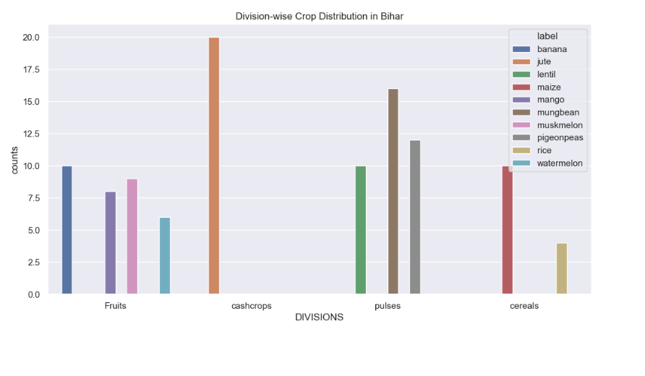

3.Histogram of Crop Counts and pH values in Chhattisgarh

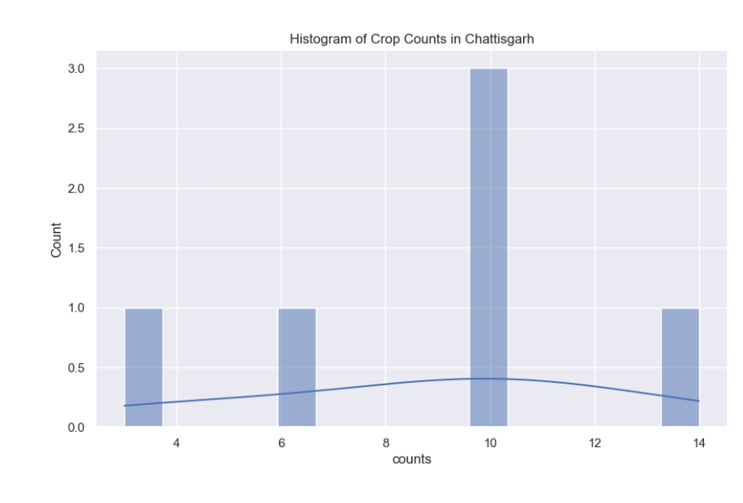

4.Pie Plot showing Crop Distribution in Haryana.

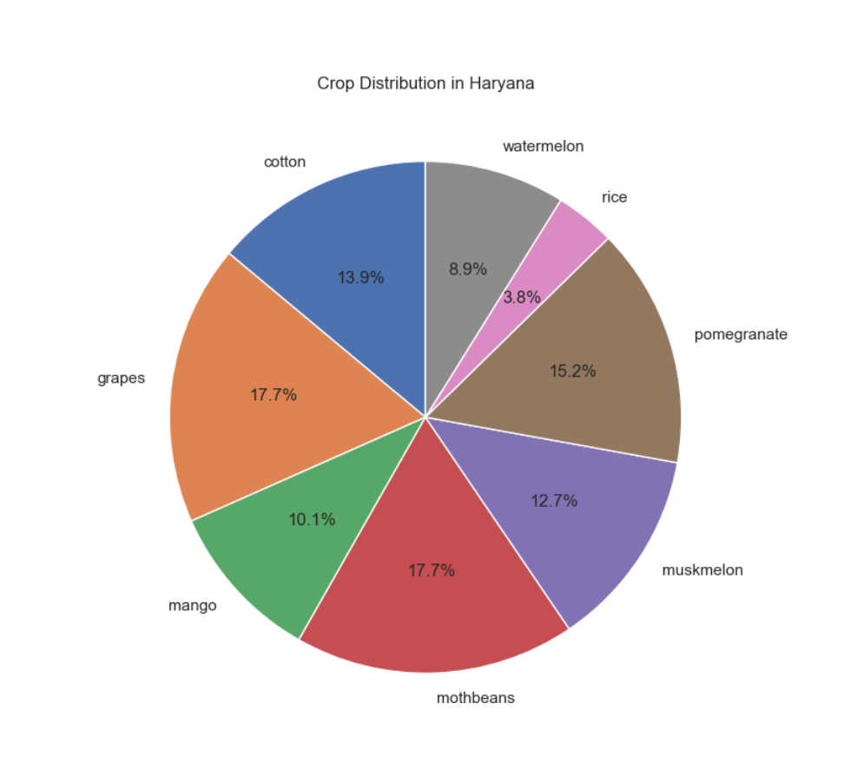

5.Division wise crop Distribution in Himachal Pradesh.

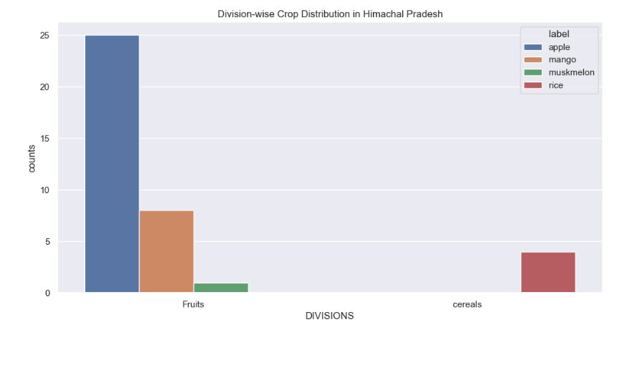

6.Crop Distribution in Jammu & Kashmir

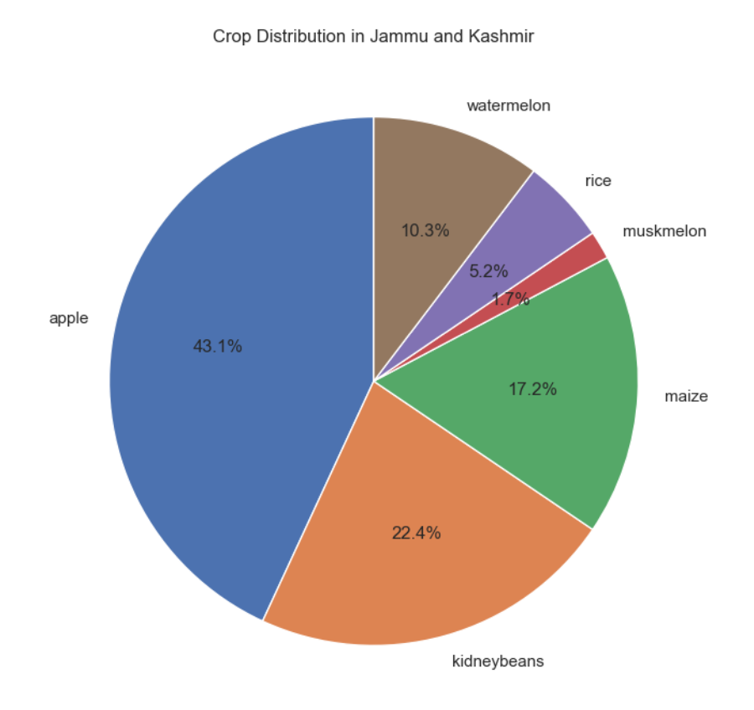

7..Average change in pH of Soil after Harvesting of Crop.

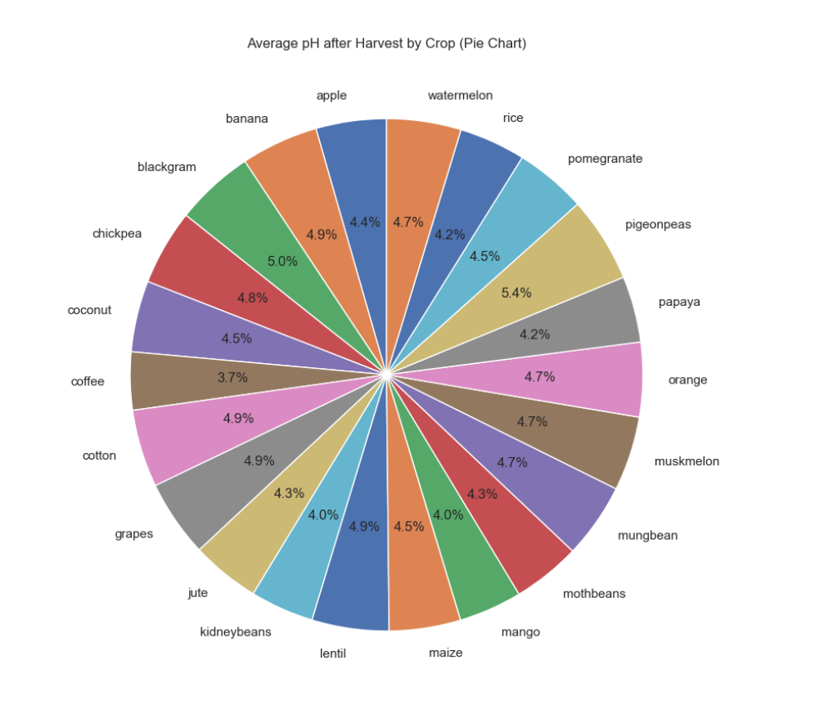

7.Division wise crop Distribution in West Bengal.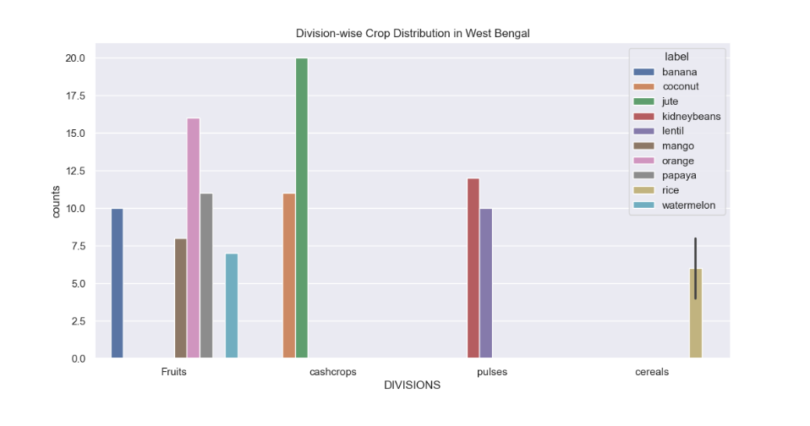

**11.CONCLUSION**

. Farm Futuro tackles the challenges posed by environmental complexities and soil health issues by implementing a Machine Learning-based crop recommendation system. This system empowers farmers with customized insights, optimizing crop selection, boosting productivity, and fostering sustainable agricultural practices.

At the conclusion point of this Project we have come up with several observations.

1.Rice is the most widely grown cereal crop in India which is grown in both Kharif as well as Rabi Season.

2.The pH of the soil experiences a change of 4-5% on an average which is the sign of land degradation.

3.Fruits cultivation is highly concentrated in few States such as Maharashtra, Karnataka and Andhra Pradesh.

4.Perennial Crops such as Coconut,Mango, Pomegranate and other crops are least recommended.

5.The regions such as North East, Maharashtra, Karnataka,Tamil Nadu have the highest variety of crops grown.

6.Some states such as Tamil Nadu and Karnataka has high percentage of cash crops and Fruits cultivation.

7.Pulses and cereals are widely grown all over India.

**Future Scope:**

The current Project has a lot of potential for growth in Future one among them is Crop Prediction System based on previously grown Crops by the Farmer on particular piece of land which helps in maintaining pH value of soil and prevents Land Degradation and increases soil fertility with minimal use of Fertilizers.

The successful implementation of FARM FUTURO has the potential to revolutionize Indian agriculture by optimizing crop selection, enhancing productivity, and promoting sustainable agricultural practices, paving the way for a brighter future for Indian farmers and the nation as a whole.